**What is ChatGPT?**

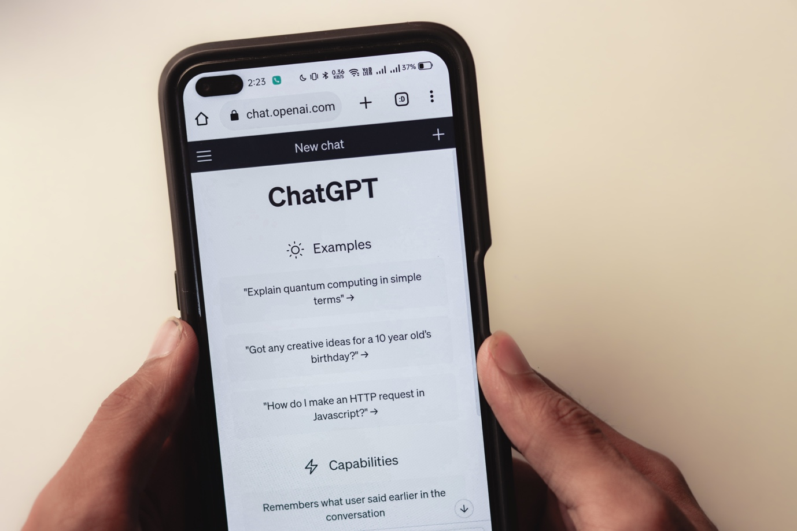

ChatGPT is an AI (Artificial Intelligence) language model developed by OpenAI, based on the GPT-4 architecture. GPT stands for "Generative Pre-trained Transformer," which refers to the underlying technology that enables the AI to understand and generate human-like text. ChatGPT has been trained on a diverse range of topics and can engage in conversations, answer questions, and provide assistance on various subjects. It is designed to be a conversational partner and can generate coherent, contextually relevant, and sometimes creative responses.